**Indicators Introduction**

* Indicators are weak acids or bases, where the conjugate acid/base pairs have different colours even at low concentrations. Indicators are generally large organic molecules.
* The colour change and the pH where this change occur, depends on the acid/base pair. (see table below)

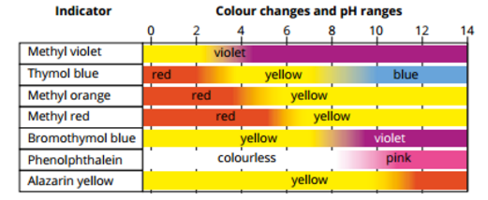

* In solution, the weak acid is in equilibrium with the conjugate base. The general relationship is often expressed as follows.

HIn(aq) + H2O(l) ⇌ In−(aq) + H3O+(aq)

Where:

* HIn is the protonated indicator (the weak acid).
* In- is the deprotonated form (the conjugate base).

**Indicator Examples**

**Litmus Paper**

* An absorbent paper that has been soaked in a mixture of indicators extracted from lichen. There are two types of litmus paper blue and red. Blue litmus paper turn red in acid, red litmus paper turns blue in a base. The colour change occurs over a range of pH from 4.5 to 8.3

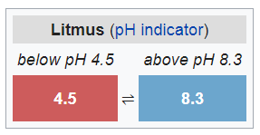

**Universal Indicator**:

* A mixture of indicators that gives a spectrum of colours over a wide pH range.

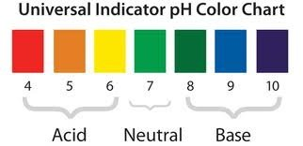

**Bromothymol Blue**

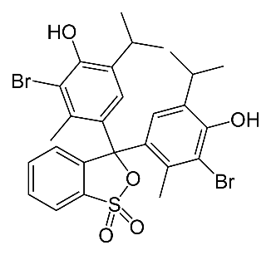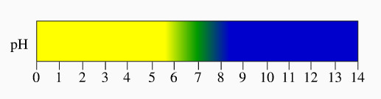Bromothymol blue is a commonly used indicator that has a yellow acidic form and a blue conjugate base.

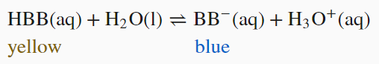

HBB is the protonated acid form

BB- is the deprotonated conjugate base

The **transition point** refers to the point when the concentrations of HBB and BB- are equal. At the transition point**,** the bromothymol blue solution is neutral, and it looks greenish due to the combination of both yellow and red.

Adding this indicator to acid increases the H3O+ ion concentration and shifts the equilibrium to the left and it will turn yellow.

When bromothymol blue is added to a base, the OH- ions combine with any H3O+ ions producing water. This lowers the OH- ion concentration slightly, shifting the equilibrium to the right turning the solution blue.

It is more common however for the OH- to react with the HBB due to its higher concentration, the forward reaction can be written as:

This reaction would be responsible for the majority of the shift to the right and therefore colour change.

**Methyl Orange**

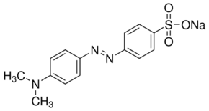Methyl orange is a synthetic indicator that has a red acid form and a yellow conjugate base. This colour change occurs between 3.1 and 4.4, and the transition point is orange in colour.

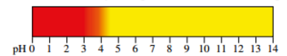

**Phenolphthalein**

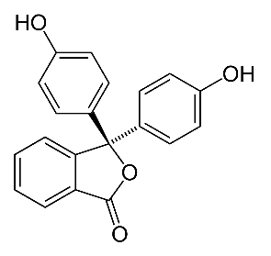Phenolphthalein is a synthetic indicator that has a colourless acid form and a pink conjugate base. This colour change occurs between 8.3 and 10.0, and the transition point is light pink in colour.

